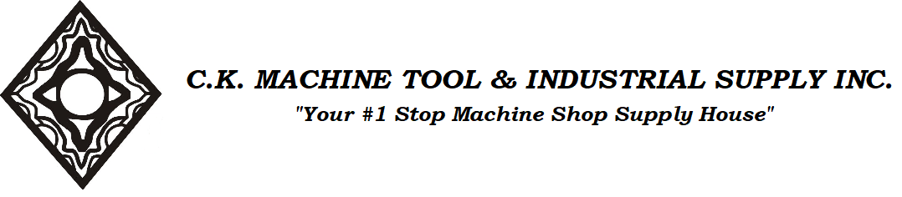
Inventory Blow Out While Supplies Last!!!

SE901
3M 60923 Filter 2/PKG
$20.99 per pkg

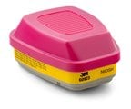

- NIOSH approved for protection against certain organic vapors, acid gases and particulates
- Swept-back design allows an enhanced field of view and comfort
- Bayonet compatibility allows use with many 3M™ half and full facepieces and certain 3M™ Scott™ full facepieces
- Wide range of applications reduces inventory needs

C.K. Machine Tool & Industrial Supply Inc.
160 Wyatt Road.
Winnipeg, Manitoba R2X2X6
T: 204-927-5659 F: 204-927-5656 E: sales@ckmachinetool.com

